Prosperity Prognosticator: Machine Learning for Startup Success Prediction
Introduction
Project Title :Prosperity Prognosticator: Machine Learning for Startup Success Prediction
Team Members
- Pathakota Harinath
- Bodimani Yagna Deepika
- Shaik Asreen
- Derangula Rupa
In today’s rapidly evolving entrepreneurial ecosystem, startups play a crucial role in driving innovation, employment, and economic growth. However, a significant number of startups fail within their early years due to factors such as insufficient funding, poor market fit, weak business models, and lack of strategic planning. Traditional evaluation methods for startup success often rely on intuition, limited experience, or incomplete information, which may lead to inaccurate decision-making.
To address this challenge, this project proposes Prosperity Prognosticator, a machine learning–based system designed to predict the success of startups using historical data and key business attributes. By leveraging data-driven techniques, the system aims to assist entrepreneurs, investors, and stakeholders in making informed decisions and minimizing business risks.
Project Overview
Purpose
The primary purpose of this project is to build an intelligent prediction system that estimates the likelihood of startup success based on historical patterns and quantitative features. The system helps users analyze startup viability before investing significant time, effort, or financial resources.
This project demonstrates the practical application of machine learning techniques in solving real-world business problems and highlights how predictive analytics can support strategic decision-making.

Objectives
- To collect and preprocess real-world startup datasets
- To perform exploratory data analysis and visualization
- To train and evaluate machine learning models for startup success prediction
- To deploy the trained model using a web-based interface
- To provide a user-friendly system for real-time prediction

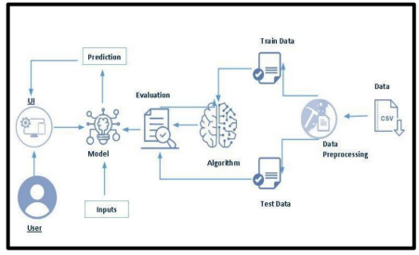
System Architecture
The system follows a three-tier architecture, ensuring modularity and scalability.
Presentation Layer (Frontend)
The frontend is developed using Flask templates, HTML, and CSS. It provides an interactive interface where users can enter startup parameters and view prediction results.
Application Layer (Backend)
The backend is implemented using Python Flask, which handles:
- Input validation
- Loading of trained machine learning models
- Prediction logic
- Communication between frontend and model
Data Layer
The data layer consists of:
- A historical startup dataset stored in CSV format
- A trained Random Forest model stored using Joblib

Project Structure
The project follows a modular and well-organized directory structure to ensure maintainability, readability, and ease of deployment. Each component of the system is logically separated based on functionality such as user interface, backend logic, dataset handling, and machine learning model storage.

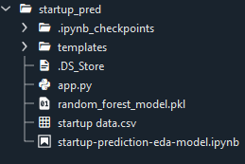
Project Directory Structure

Dataset Description
The dataset used in this project was collected from Kaggle, an open-source platform that provides real-world datasets for research and learning. The dataset contains multiple attributes related to startup funding, milestones, age, and business relationships.
Dataset Link
https://www.kaggle.com/datasets/manishkc06/startup-success-prediction
The dataset is cleaned and analyzed to remove inconsistencies and irrelevant features before being used for model training.

Exploratory Data Analysis (EDA)
Exploratory Data Analysis is performed to understand the underlying structure of the data and to identify meaningful patterns. Various statistical and visualization techniques are applied to analyze the relationship between startup attributes and success outcomes.
Visualization Techniques Used
- Bar charts for categorical distributions
- Pie charts for proportion analysis
- Line charts to analyze trends over time
- Correlation heatmaps to identify influential features
EDA helps in feature selection and improves the overall performance of the machine learning model.

Data Preprocessing
Data preprocessing is a critical step in machine learning. In this project, preprocessing includes:
- Handling missing values
- Reducing the number of categories by grouping less frequent values
- Encoding categorical variables
- Dropping irrelevant or redundant columns
By performing preprocessing, the dataset becomes suitable for training reliable and accurate models.

Model Building
Multiple machine learning algorithms are evaluated during the development phase. The Random Forest Classifier is selected as the final model due to its robustness, ability to handle complex feature interactions, and resistance to overfitting.
Model Training
- The dataset is split into 70% training data and 30% testing data
- The model is trained using labeled startup success outcomes
Model Evaluation
The model performance is evaluated using:
- Accuracy score
- Confusion matrix
- Classification report
The final model achieves satisfactory performance on unseen test data, making it suitable for deployment.

Model Deployment
After training and evaluation, the best-performing model is saved using the Joblib library. The saved model is integrated with a Flask web application to enable real-time predictions.
The deployment process ensures that the model can be reused without retraining and accessed easily through a browser-based interface.

Web Application Interface
The web application provides a simple and intuitive interface where users can enter startup parameters such as:
- Age at first and last funding year
- Number of funding rounds
- Total funding amount
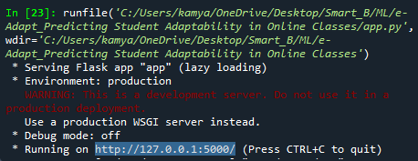
- Number of milestones
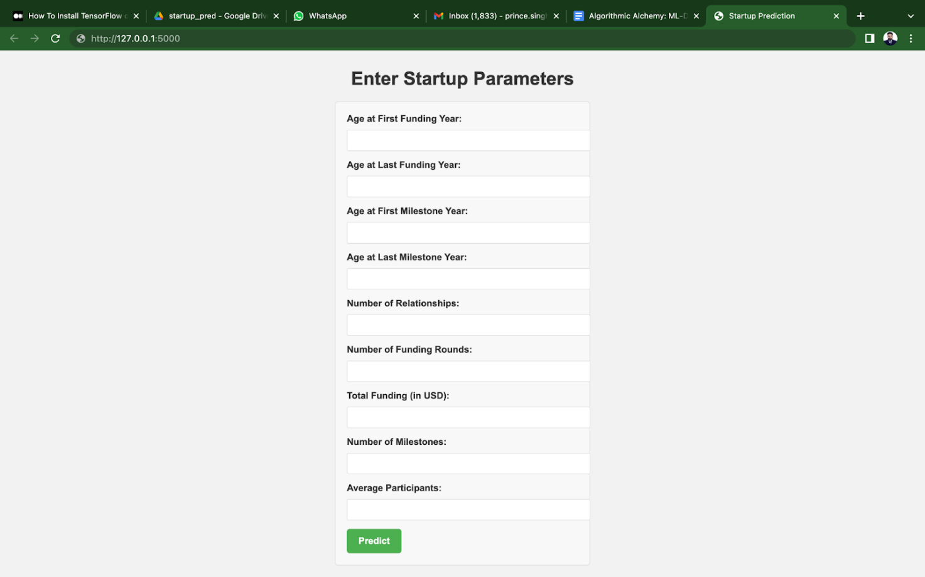
Once the user submits the data, the application displays the predicted startup success result.

Testing & Validation
Comprehensive testing is conducted to ensure system reliability:
- Functional Testing: Verifies input validation, navigation, and prediction output
- Performance Testing: Ensures quick response time
- User Acceptance Testing (UAT): Confirms system readiness for real-world use Testing results indicate that the system performs reliably under expected conditions.

Known Limitations
- The prediction accuracy depends on the quality and size of the dataset
- Limited features may restrict generalization
- Real-world startup success may be influenced by external qualitative factors

Future Enhancements
- Integration with cloud platforms (AWS / GCP / Azure)
- Use of advanced models such as XGBoost or Neural Networks
- Role-based authentication for secure access
- Inclusion of additional datasets for improved accuracy
- Advanced dashboards and analytics

Conclusion
The Prosperity Prognosticator project successfully demonstrates how machine learning can be used to predict startup success using historical data. By integrating data preprocessing, exploratory analysis, model training, and web deployment, the system provides a complete end-to-end solution.
This project highlights the importance of data-driven decision-making in entrepreneurship and serves as a scalable foundation for future improvements. It effectively combines machine learning, software engineering, and agile practices to deliver a practical and impactful solution.

Reference
Reference: Self-defined project implementation based on project analysis and team discussion

